**Visualize data with QuickSight**

**In this project we are going to Create an S3 bucket to store your dataset files. Upload the CSV file to your bucket. Modify and upload the manifest.json file to the bucket.**

**Step 1: Create bucket give it a name**

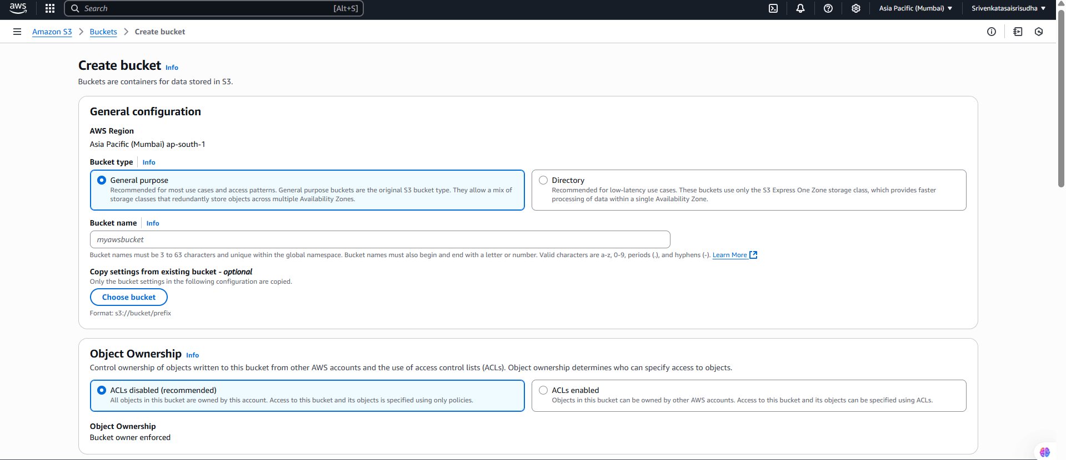

**Step 2 : Upload the files which we wanted to analyse**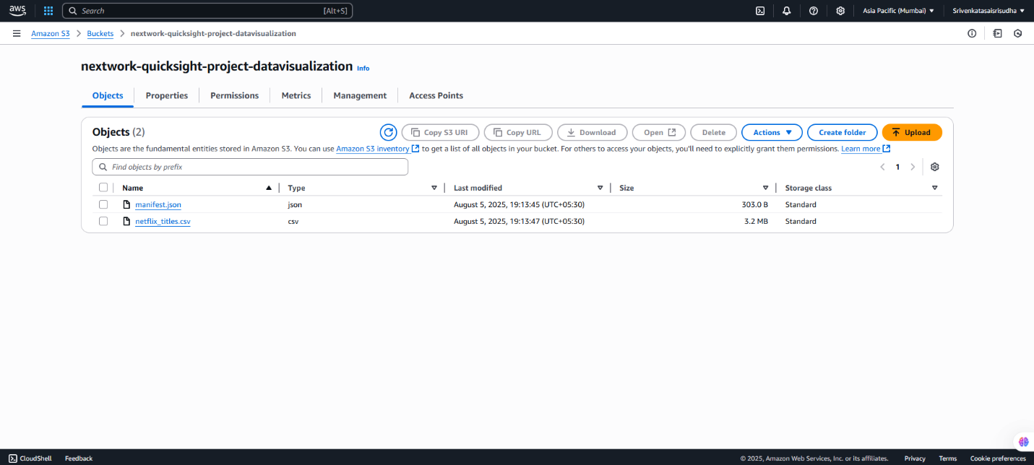

**Step 3: select the csv file and click copy s3 URL**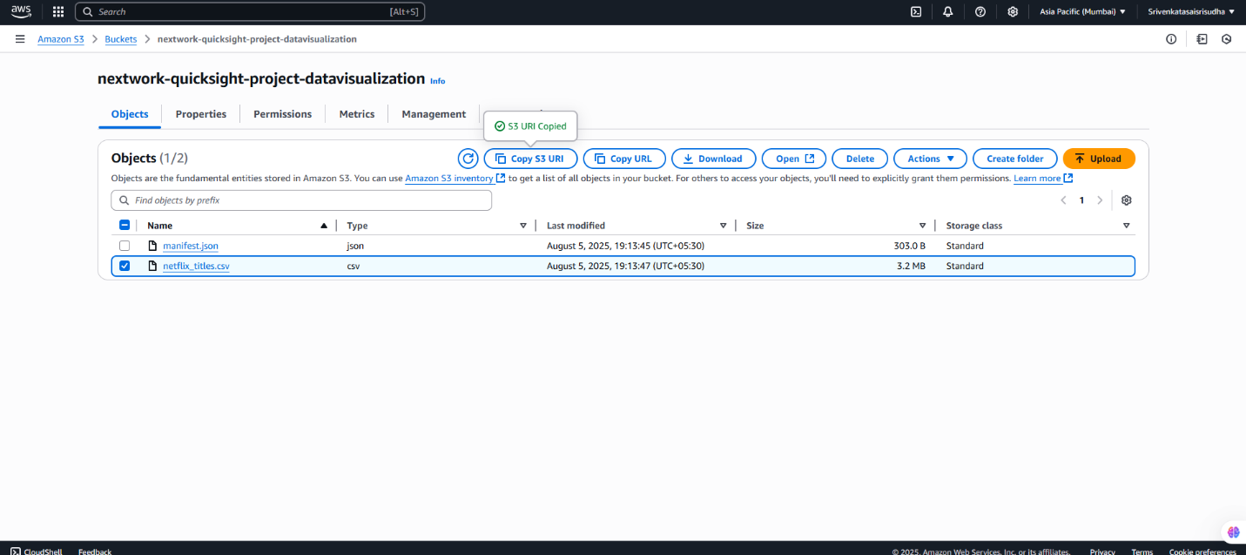

**Step 4 : Open the downloads folder and click on json file and in the URIs add the copied URI as shown below.We are doing this to qicksight know the location of s3 bucket**

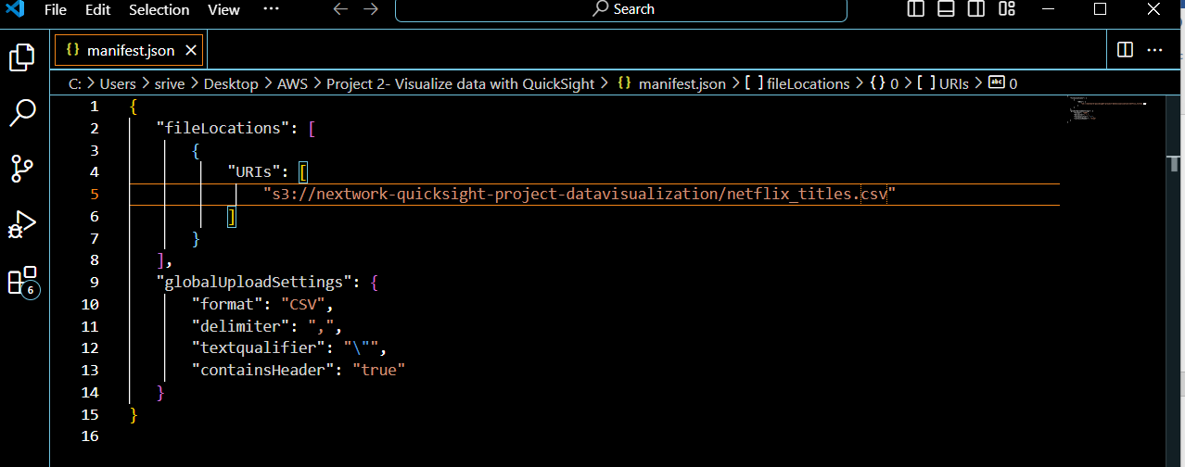

**Step 5 : now save the file and click on upload and add the updated json file, it automatically replaces.**

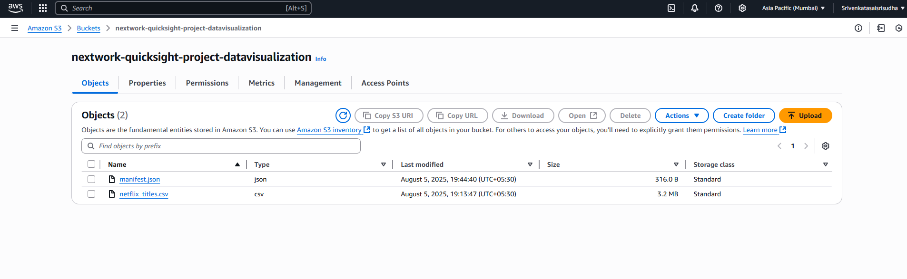

**What is Amazon QuickSight**

**Amazon QuickSight is a cloud-based business intelligence (BI) service offered by AWS that helps you analyze data and share insights through interactive dashboards, visualizations, and reports.**

**Step 1: Search of quicksight and signup**

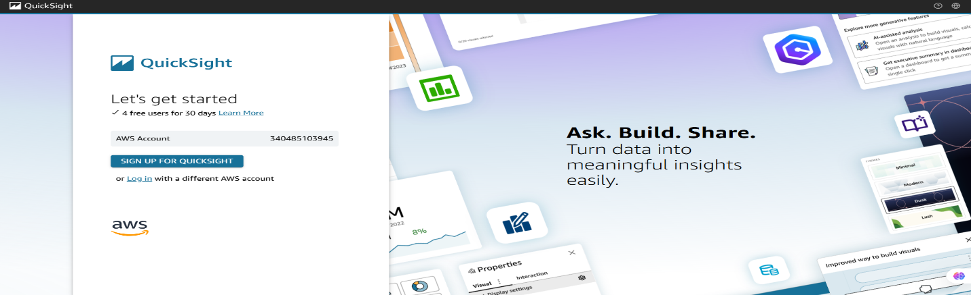

**Step 2: Add the following details**

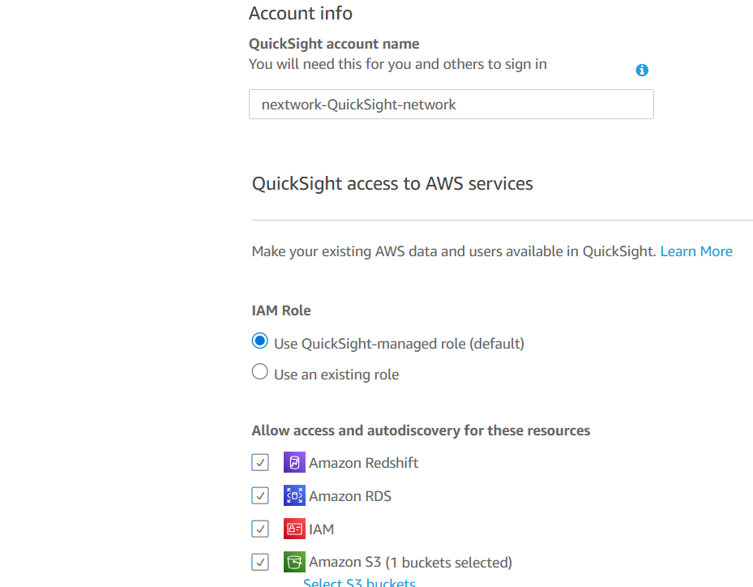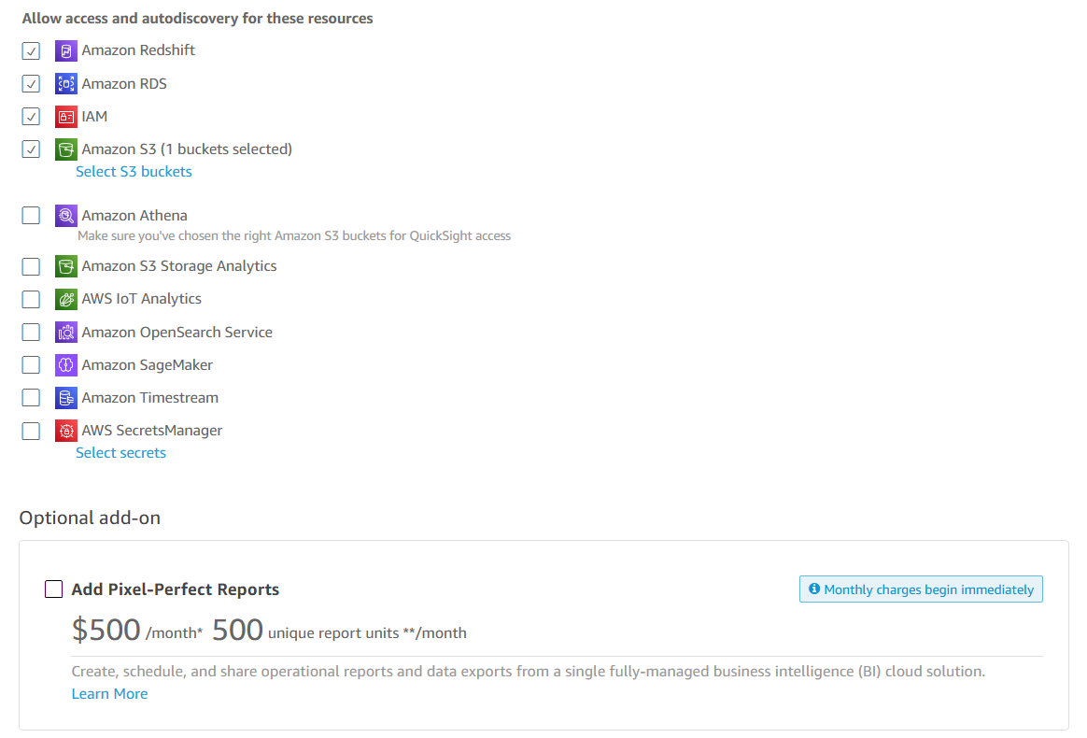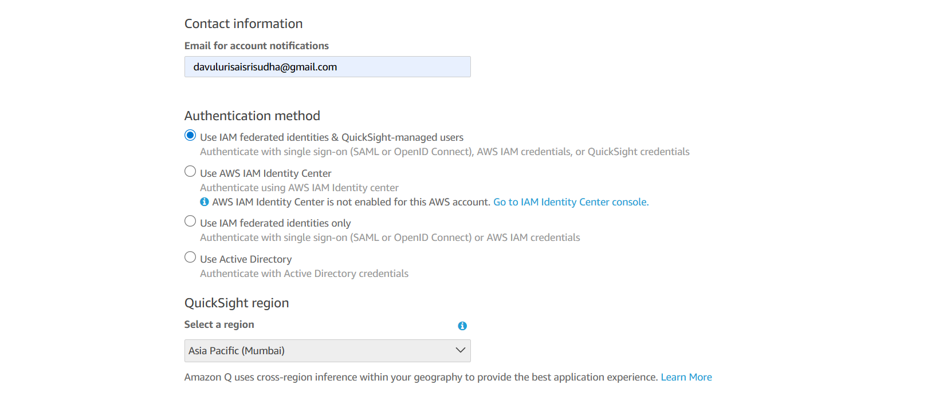

**It takes a while to create the account, below is the dashboard**

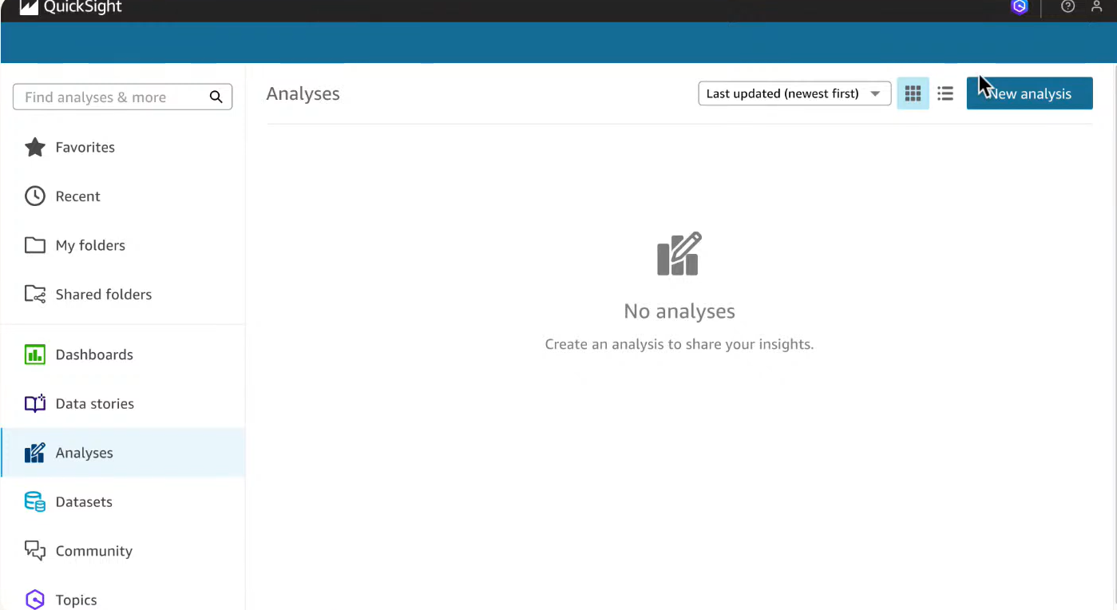

**Step 3 : click on new dataset ,choose s3 and give it a name,add the URI from the s3 and paste as shown in the picture and click on visualize**

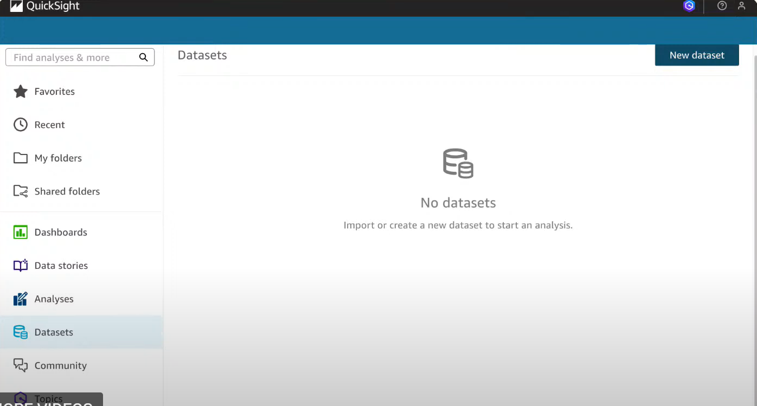

**what does the manifest.json file do?**

**manifest.json tells QuickSight what your dataset looks like, so QuickSight knows how to understand the data and show it in charts or graphs. Without this map, QuickSight might get confused and not show your data correctly.**

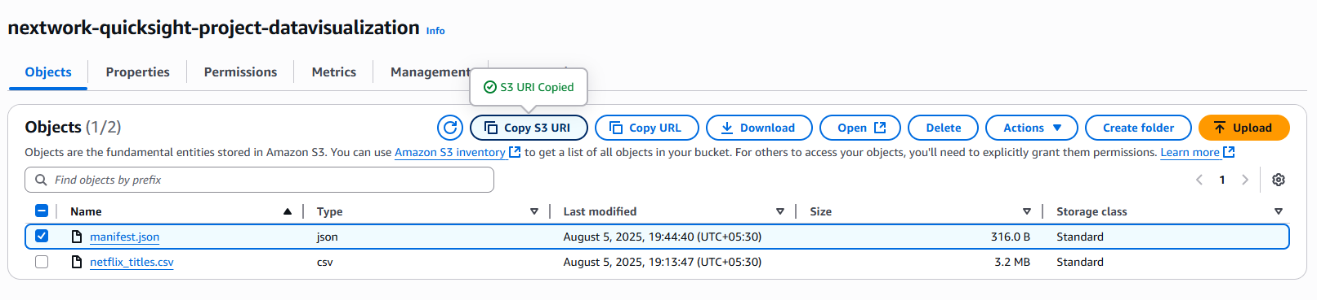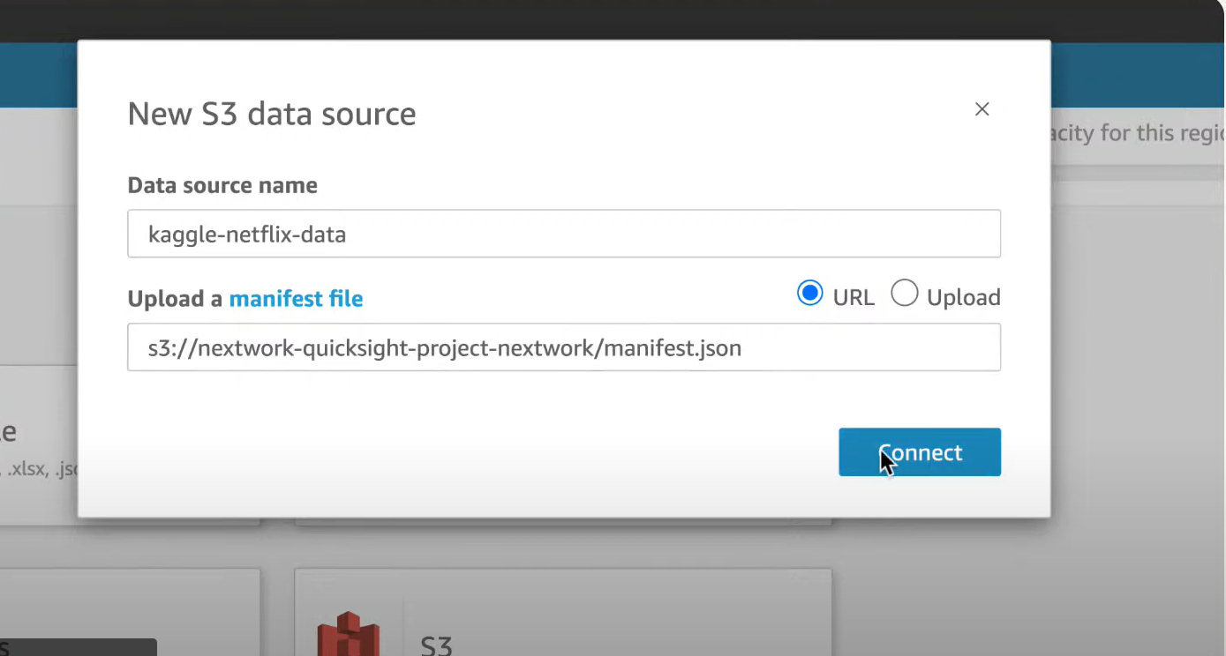

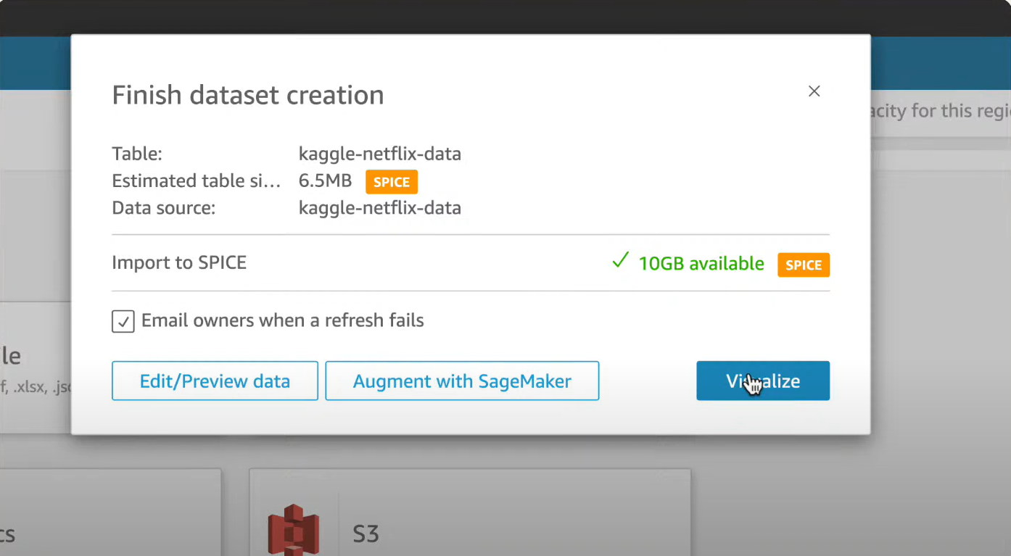

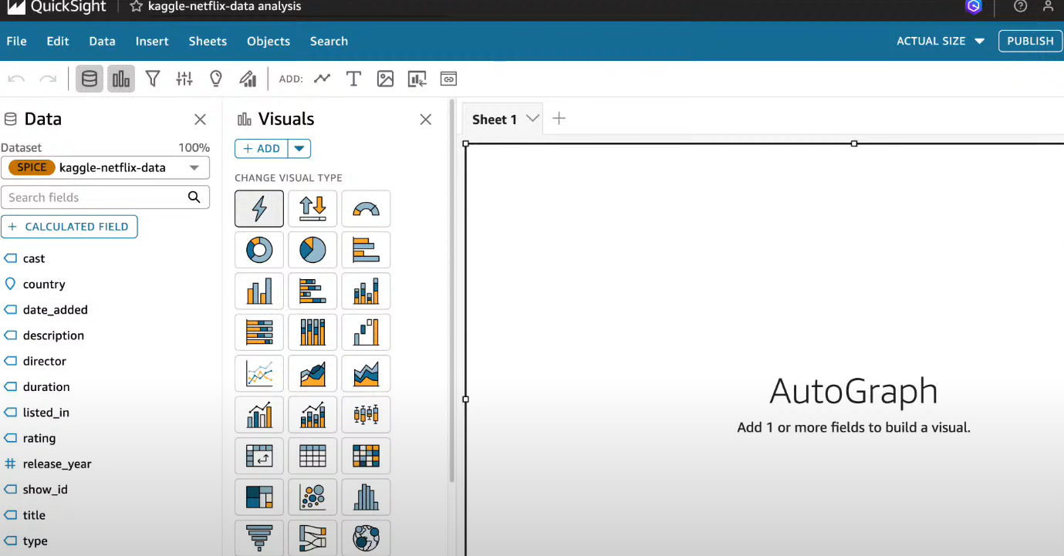

**This is the page we will land.**

**Step 4: drag #release_year now we would like to see in pie chart as shown in figure**

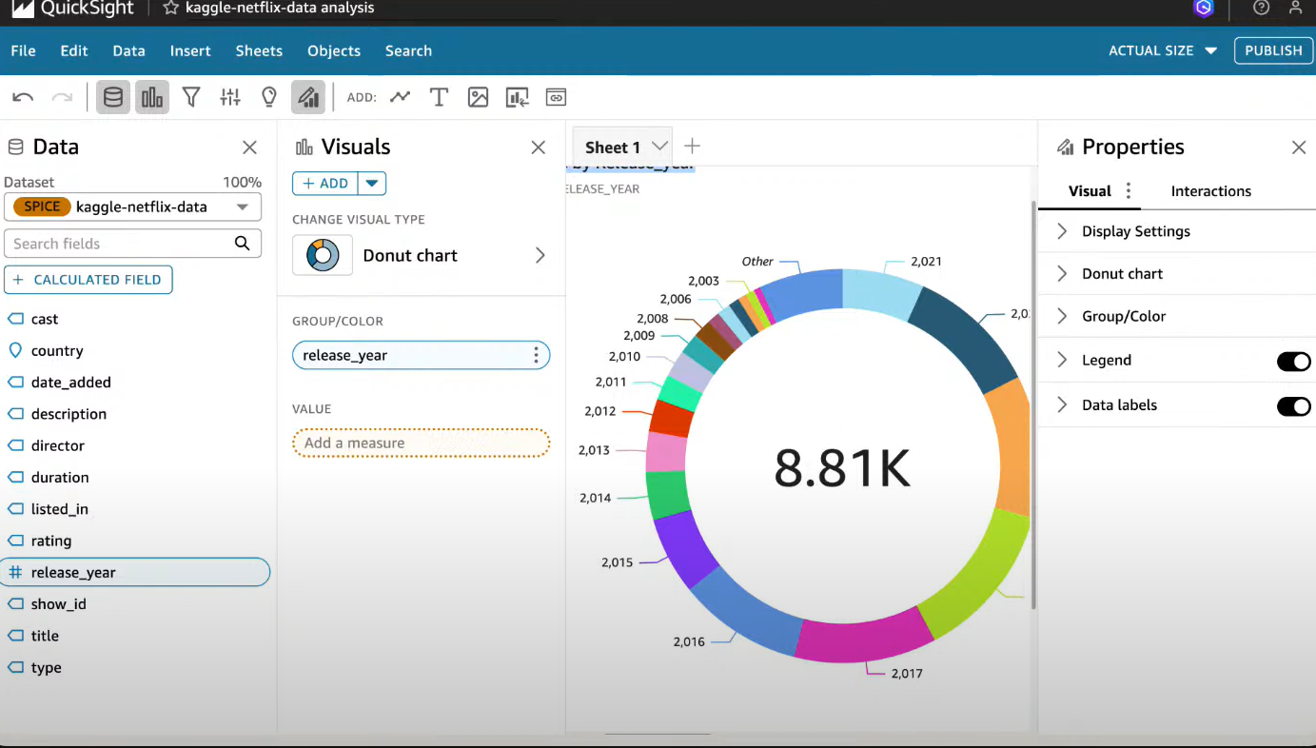

**Under Visuals add more and create more visuals as required**

**The below shows the count of records by release_year and type which is added in group**

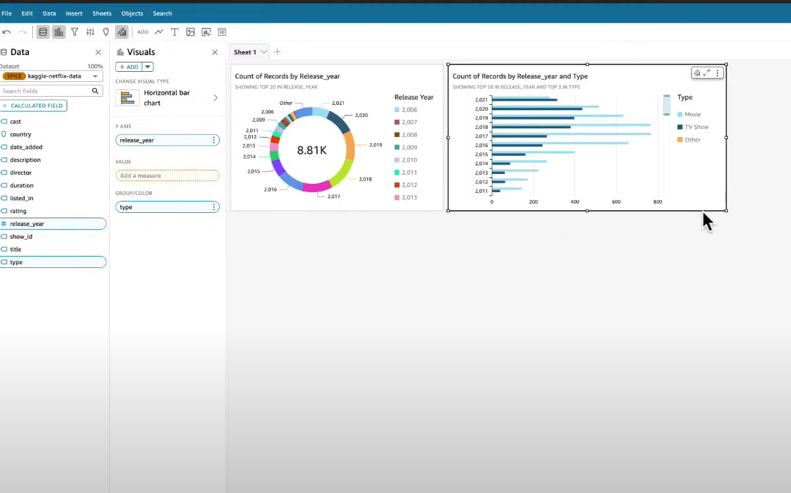

**When the data is having duplicates and missing values we need to remove those and again upload it into csv file using the above steps mentioned and URI has to be updated in json file and it automatically updates but the graph has the same**

**Step 5: Go to data tab -> Datasets**

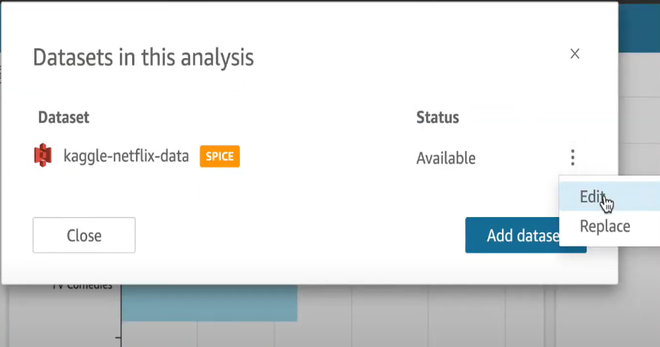

**Step 6: A new space appears,Theres a option beside query mode click to refresh and click on OK**

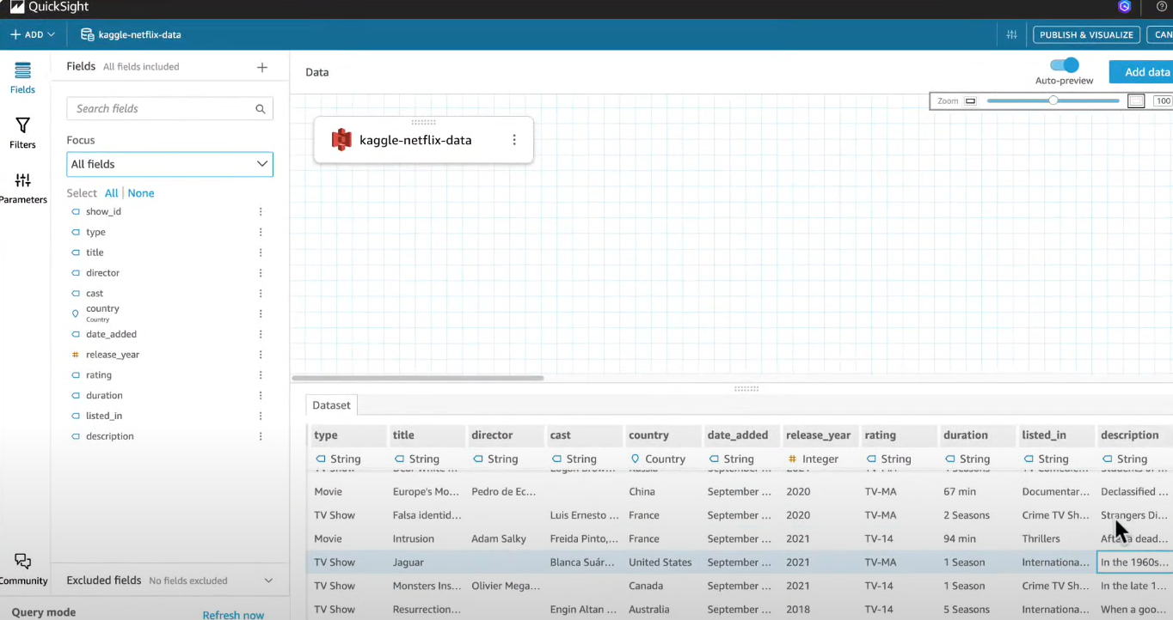

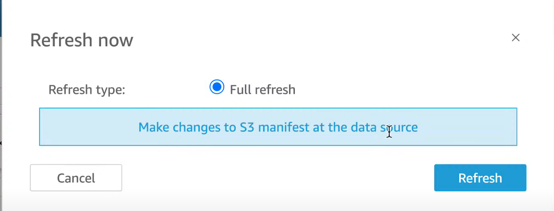 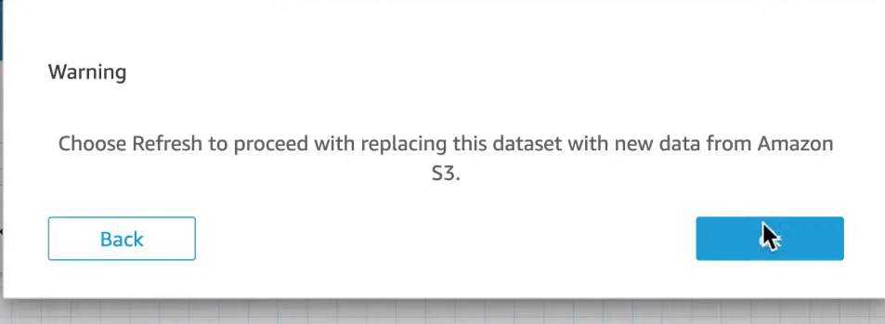

**Step 7 : Click on Quicksight icon and go back to the dashboard and analyses. Now it is updated data**

**Step 8: Give the Graphs titles and reaarange as required by renaming etc by doubleclicking.**

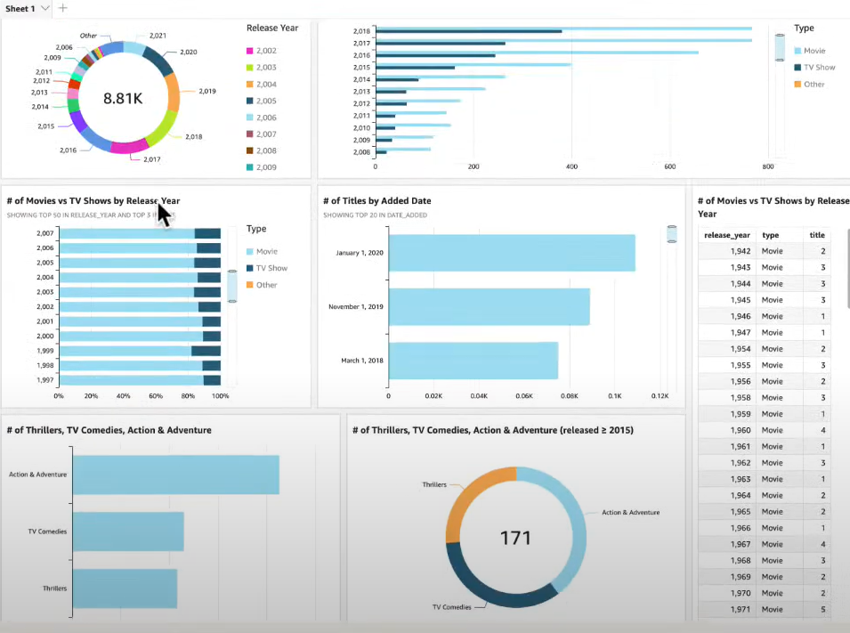

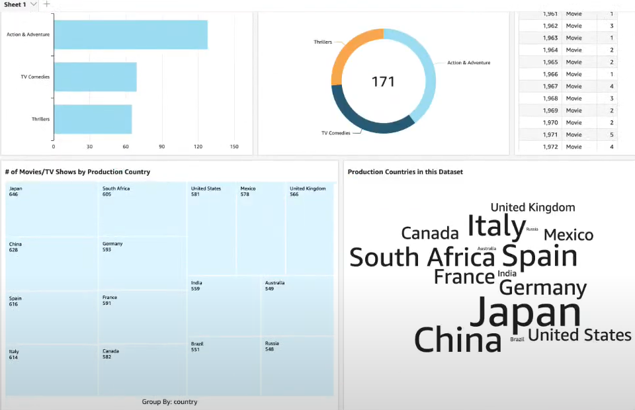

**Step 9: Click on Publish on top right corner**

**Step 10: A dialouge box appears as below and click on publish dashboard after naming it**

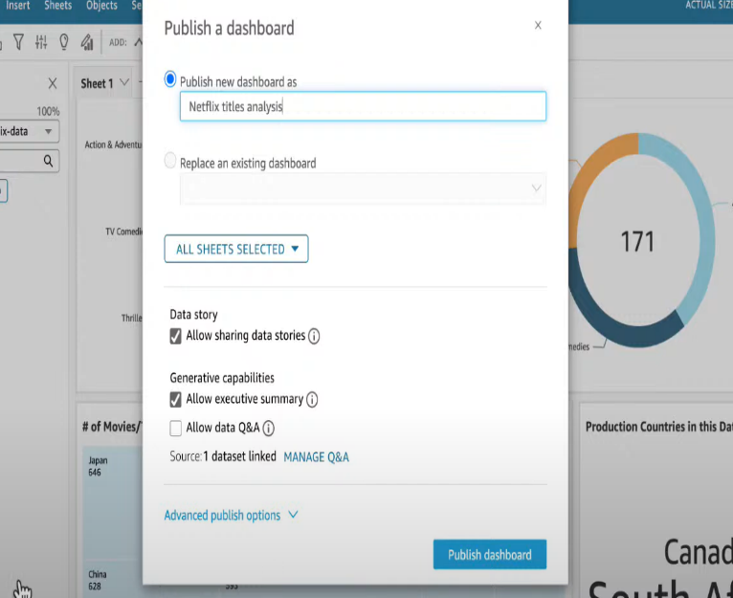

**Step 10: Download the dashboard as PDF as shown below**

* 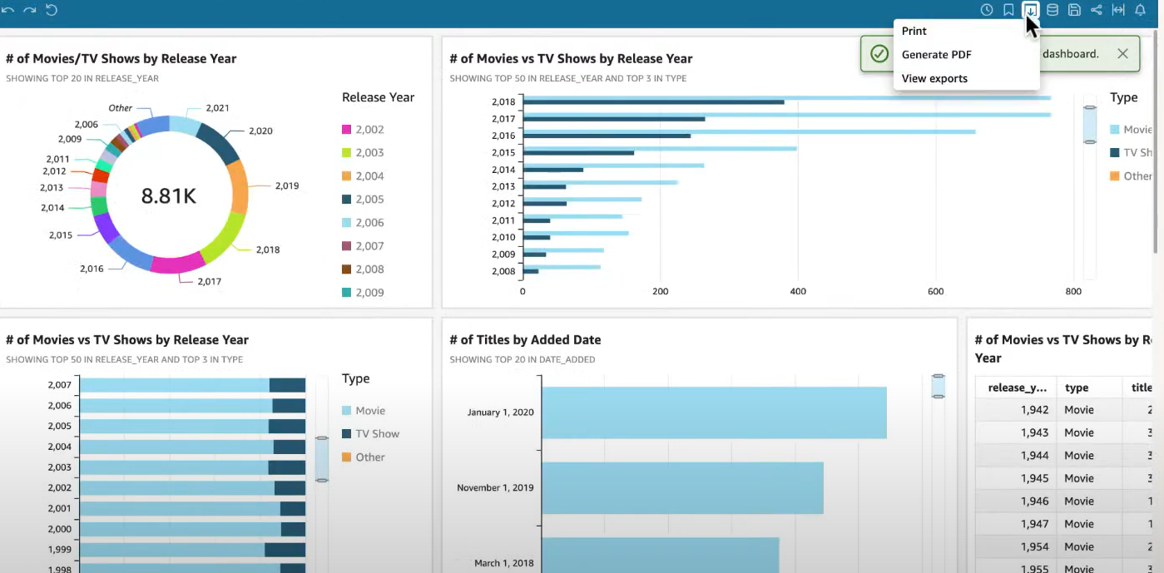

**Key Concepts Learned: manifest.json, data visualization techniques including charts ,filters and to perform data refresh in quicksight.**

**How To Delete The Quicksight Account**

**Step 1: on the top right corner go to manage quickSight**

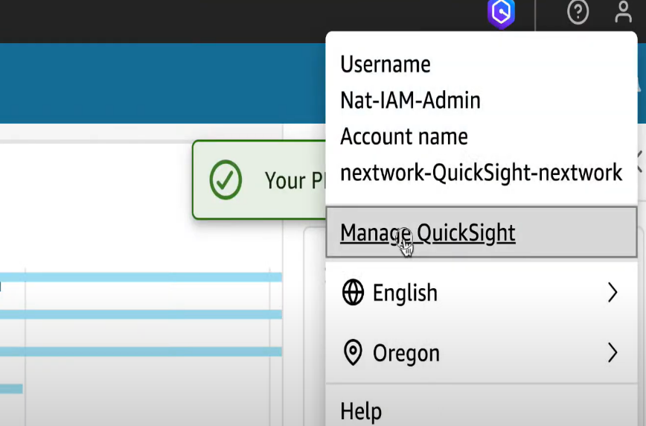

**Step 2: Go to Account setting and click on Manage**

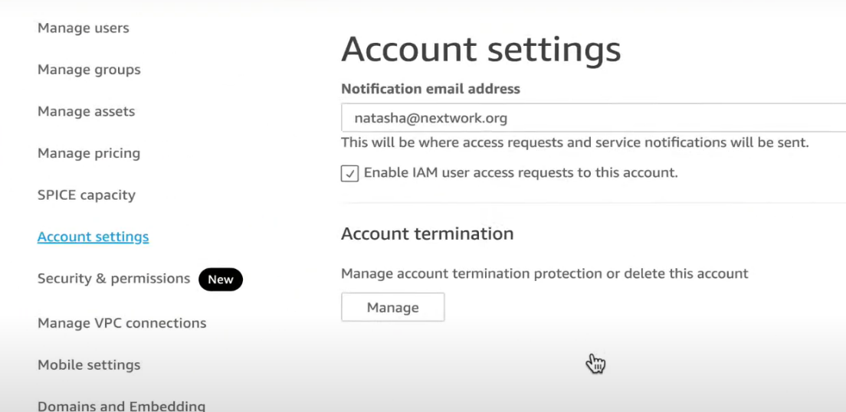

**Step 3: Turn off Account termination protection and type confirm to delete the account.**

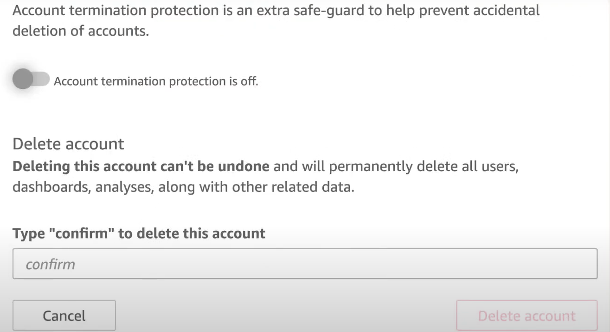

**Delete The Bucket Now**

**Step 1 :Go to General Bucket and click on delete**

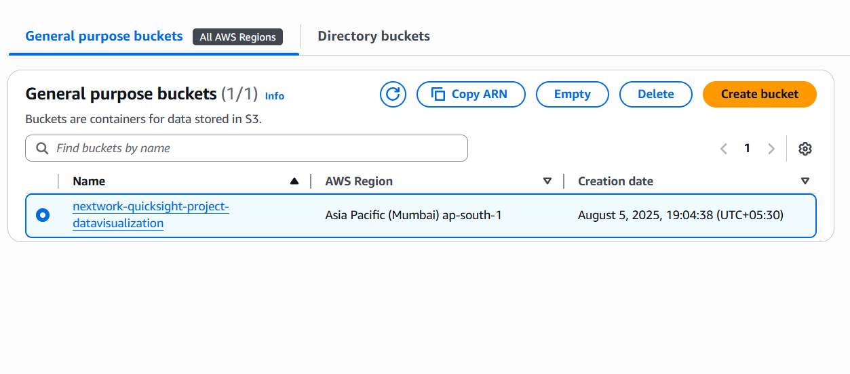

**Step 2: Empty the bucket**

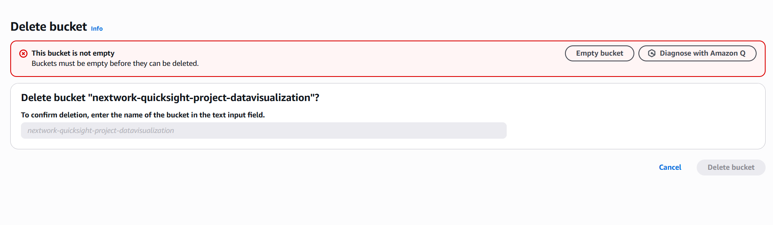

**Step 3: Write permanently delete and click on empty**

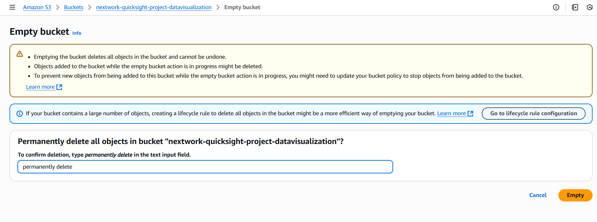

**Step 4: Now the bucket is empty**

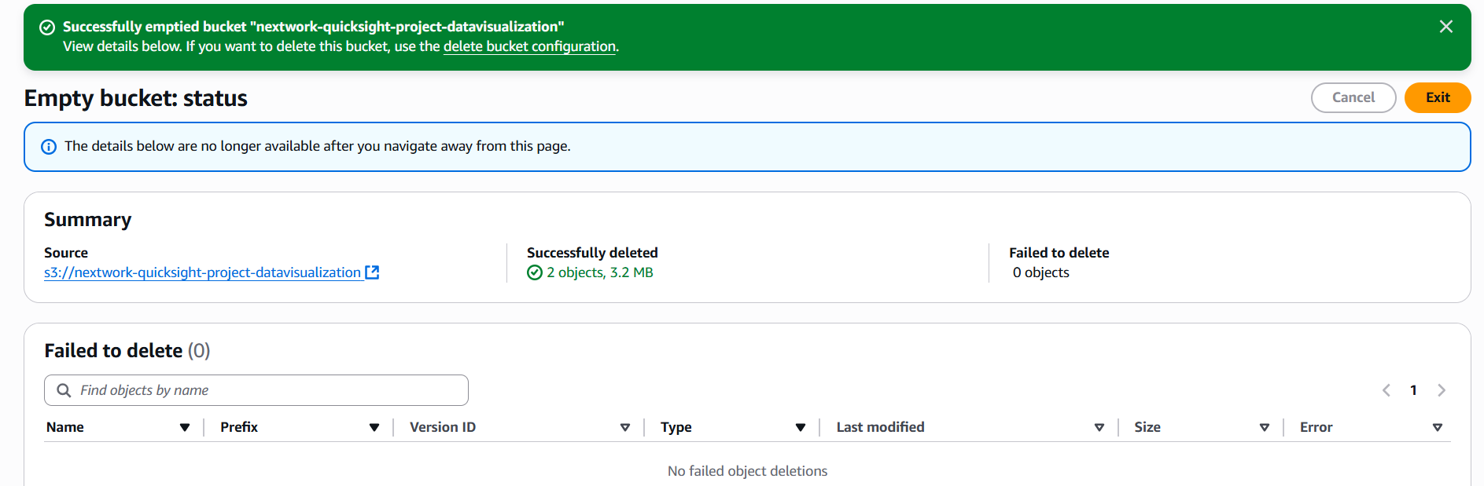

**Step 5: Click Exit , Select the bucket and click on delete**

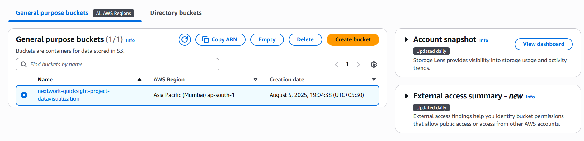

**Step 6:** **Rewrite the project name and delete the bucket**